V&V MANUAL TESTING
Mini Project
University Admission System

Document Revision History

Date | Revision No. | Author | Summary of Changes
November, 2010 | 1 | Vaishali Kulkarni | Initial Draft
July, 2015 | 1.2 | Shilpa Bhosle | Implemented changes as per integrated syllabus
August, 2016 | 2.0 | Shilpa Bhosle | Implemented changes as per integrated syllabus

Table of Contents
Introduction 4
Setup Checklist 4
Instructions 4
Problem Statement 5
Objective 5
Abstract of the project 5
Functional components of the project 6
Technology used: 7
Implementation 8
Summary of the functionality to be built: 8
Guidelines on the functionality to be built: 9

Introduction
This document outlines a mini project for the V&V Manual Testing LOT. The project is to test an Online University Admission System. This document contains the work flow of the system and gives guidelines on how to test the functionality gradually in each of the course modules of the V&V Manual Testing LOT.

Setup Checklist
Minimum System Requirements
- Intel Pentium 4 and above Windows XP, 7
- Memory 1 GB
- Internet Explorer 10.0 or higher
- MS Office 2010 Suit or higher
- UNIX Server Connectivity

Instructions
- All the artifacts related to Mini Project, i.e. Requirement Itemization template, Use Cases, Test Cases, TBA template & Defect Report should follow the guidelines.
- Create a directory by your name in drive D. In this directory, create a subdirectory MiniProject<Groupcode>. Store your Project here.
- You can refer to your course material.
- You need to follow the Mini-Project Schedule given in this document.

Problem Statement

Objective

To test University Admission System
Abstract of the project

This project is aimed at test an online University Admission System (UAS) for applicants. This is a web based application that can be accessed throughout the web. This system can be used to search a university program for which an applicant wishes to take admission; apply online for a selected university program without any login and fill up the form, administration staff can add/update/delete any program that university offers. Members of admission committee (MAC) have the responsibility to filter the candidates for a specific program on the basis of application data and interview.

Use following user credentials to access above project link.
Username | Password | Role
A1001 | admin123 | Admin
A1002 | mac123 | MAC

Functional components of the project
Following is a list of functionalities of the system. Wherever, the description of functionality is not adequate, you can make appropriate assumptions and proceed.

There are three categories of people who would access the system viz. applicants, members of admission committee (mac) and administrators. Each one of them would have some exclusive privileges (for e.g. Applicants can apply for a program by filling up the online form without any login process, members of admission committee alone will be able to view applicant details and filter the applicants for a specific program they have applied for and only the administrator has the right to keep track of the university’s program details.)

- Applicant should be able to

  - View all programs scheduled by the university
  - Apply online for a scheduled program of the university, by filling up the application form that auto generates the application ID
  - View the application status, based on the application ID

- The member of admission committee (mac) should be able to :

  - Login into the system using his/her credentials.
  - View applications for a specific program.
  - Accept/Reject an application on the basis of the details of the applicant. If accepted, fill in the scheduled date for an interview of the applicant before confirming the applicant to take the program.
  - After the interview, update the status of the application to Confirmed/Rejected

- The administration should be able to

  - login to the system using his/her credentials
  - Update and manage (add or delete) information of the programs offer by the university
  - Manage (add or delete) schedules of the programs offered by the university
  - Generate various reports like:
    - View List of applicants confirmed/ accepted (waiting for interview)/rejected for a scheduled program .
    - View list of programs scheduled to commence in a give time period

Transition of Status: Applied ->Accepted/Rejected->Confirmed/Rejected

Technology used:
    - Front End & Web Components
      - HTML/JavaScript
      - Servlets
      - JSP
    - Business Logic Components and Services
      - Java Beans
    - Application Servers
      - WildFly
    - Databases
      - Oracle 9i

Implementation

Summary of functionalities to be tested:
Sr. No | Course | Duration  (in PDs) | No. of Saturdays | Task Name
1 | Programming Foundation with Pseudo code | 3 | 3 | NA
2 | Web Basics (HTML 5, CSS 3, JavaScript, XML) | 4.5 | 3 | 1. Analyze the given  case study  2. Identifying  requirements from  given case study
3 | Introduction to SE & STLC | 1.5 | 3 | 1. Peer/Group review  of requirements  identified  2. Note  queries related to  requirements found  from given case  study
4 | DBMS/SQL | 4 | 3
5 | UNIX for Users | 2 | 3 | - Peer/Group review of queries  - Closure of queries
6 | Programming Foundation with Pseudo code + Web Basics + OOP & UML + Oracle for Developers Test | 1 | 3 | - Peer/Group review of queries  - Closure of queries
7 | Testing Concepts | 5 | 2 | - Complete Requirement Itemization  - Identify and write Use Cases from the given case study  - Write Test Cases against the requirements identified
8 | Req. Validation Func. Decomposition | 2 | 2
9 | Use cases and use case level test cases | 1 | 2
10 | Testing concepts+Requirement validation+Use case Test | 1 | 2
11 | Task Based Approach | 1 | 2 | - Peer/Group review of Requirement Itemization filled template  - Peer/Group review of Use Cases  - Peer/Group review of Test Cases  - Developing Scenario Matrix from Use Cases  - Make use of TBA template to write UCTC, Form-Level, Field-Level Test Cases
12 | Defect Reporting and Defect Life Cycle Management | 3 | 2
13 | Test Automation and tool basics (Selenium) | 2 | 2
14 | MS Office (MS Word 2010 & MS Excel 2010) | 1 | 2
15 | Task Based Approach + Defect Reporting and Defect Life Cycle Management + Selenium + MS Office 2010 Test | 1 | 2
16 | TMap | 5 | 2 | - Peer/Group review of TBA template  - Execute Test Cases on application  - Log defect in Defect Log template
17 | Test Management Tool | 3 | 2
18 | Non Functional Testing | 2 | 2
19 | Test Driven Development | 1 | 2 | - Execute Test Cases on application  - Log defects in Defect Log template  - Peer/Group review of Defect Log  - Designing Mini-Project presentation
20 | TMap + Test Management Tool + Non Functional Testing + Test Driven Development Test | 1 | 2
21 | Mini Project presentation | 1 |  | Presentation of Mini Project

Guidelines on the functionality to be tested:
- Tables
  - Following database tables were used in this application to store the information:
    - Applicantion: This will contain the list of valid applications (Applicants fill in the application form)
    - Programs_Offered: This will contain details of programs offered by the university
    - Programs_Scheduled: This will contain details of a programs scheduled by the university, among the offered programs
    - Participant : This will contain details of confirmed participants for a scheduled program
    - Users : This will contain all the valid logins and passwords, there is no screen to enter values in this table, assume that this table is present with valid data, that will be used by the application
  - The structure of the above listed tables is as follows:

    - Application : Application_id (auto generated serial no.),full_name (varchar(20)), date_of_birth (date), highest_qualification (varchar(10)), marks_obtained (number), goals(varchar(20), email_ id(varchar(20)), Scheduled_program_id(varchar(5)), status(varchar(10)),Date_Of_Interview(date)
Note :
- Possible values of status are ‘applied’ by default, ‘accepted’ ,’rejected’ and ’confirmed’

    - Programs_Offered: ProgramName (varchar(5)), description (varchar(20)), applicant_eligibility(varchar(40)), duration(number), degree_certificate_offered(varchar(10))

    - Programs_Scheduled : Scheduled_program_id (varchar(5)), ProgramName (varchar(5)), Location (varchar(10)), start_date (date), end_date (date), sessions_per_week(number)
Note :
- Location can be normalized since it would contain further information like city, state, zipcode etc
- No. of seats for a program are not limited

    - Participant : Roll_no (varchar(5)), email_id (varchar(20)), Application_id (FK) , Scheduled_program_id(varchar(5))

    - Users : login_id(varchar(5), password(varchar(10)), role(varchar(5))

Note :
- Possible values of role are ‘admin’,’mac’

The functionality and components to be test in each of the module is as follows:

  - Requirement for the application:
    - View Scheduled Programs screen: This page provides the applicant with
information related to programs scheduled by the university, this screen
has a link to ‘Apply Online’

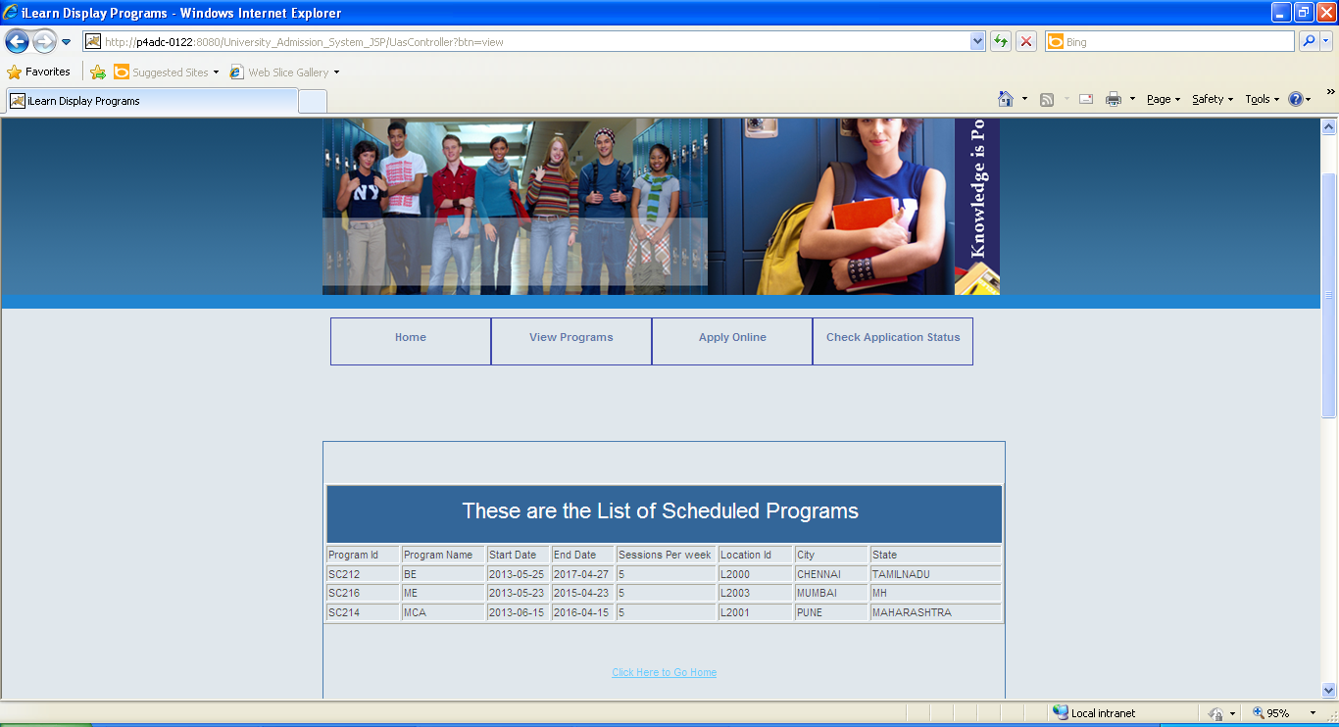
    - Apply Online: Allows an applicant to fill in and submit application form for
a scheduled program, an applicant ID is auto generated.
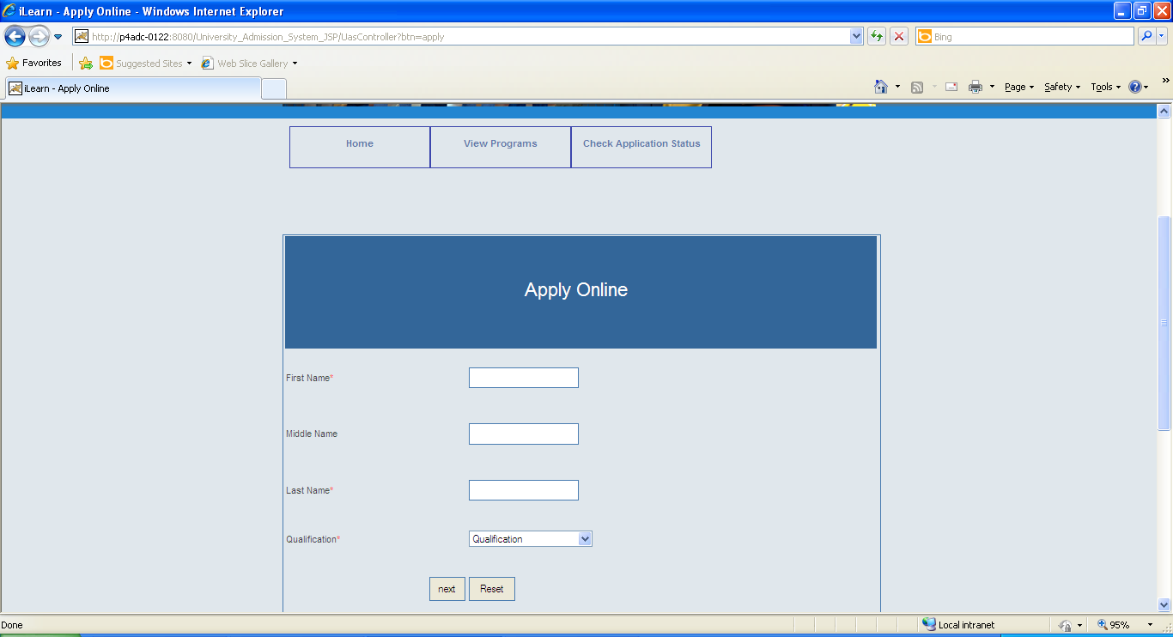
    - View Application Status: An applicant should be able to view the status of
application by entering the Applicantion_id
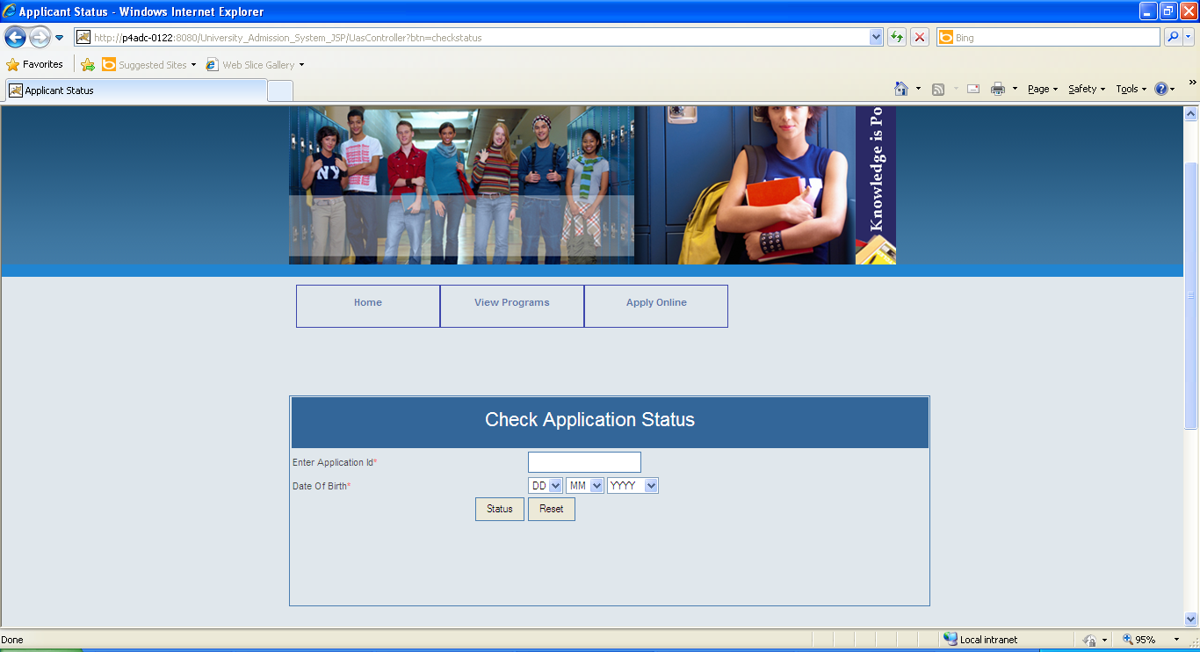
    - Maintain Information on Programs Offered and Scheduled: This
functionality should be available only for authorized administrators.
Administrations maintain valid information about programs offer and
scheduled by the university (add new / delete existing). Update only
programs offered information and updatable data includes Program
description, applicant eligibility.

- Admin Screen
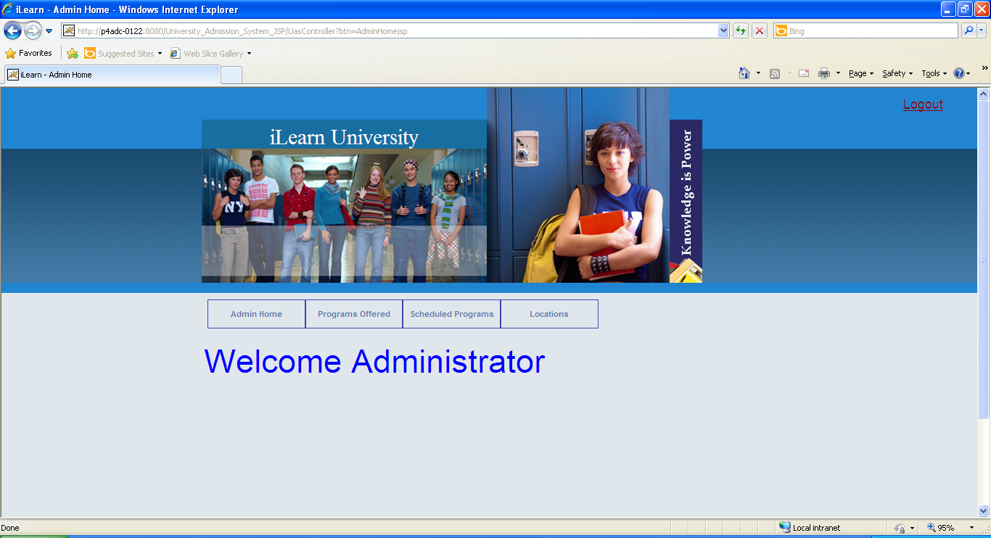

- Add Program Screen

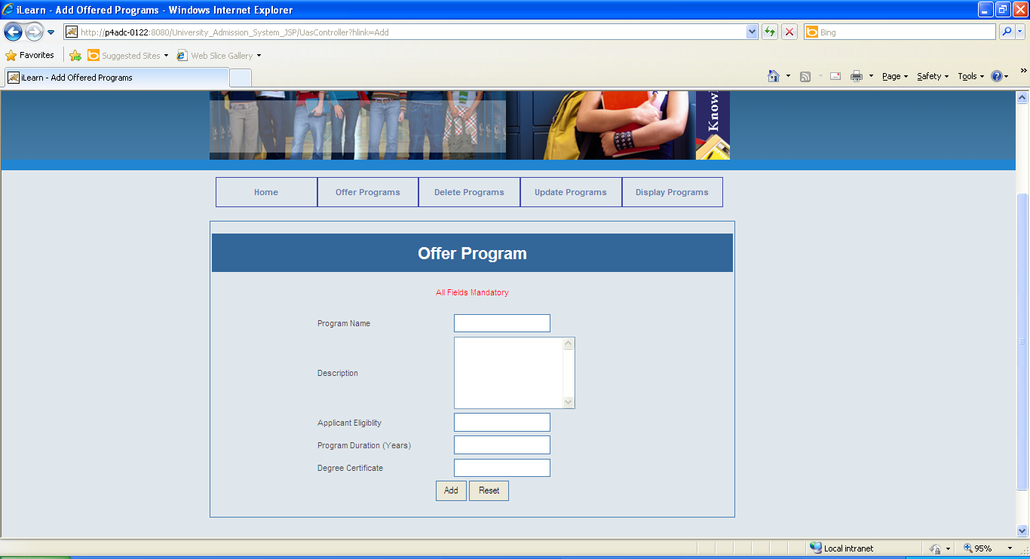

- Delete Program Screen
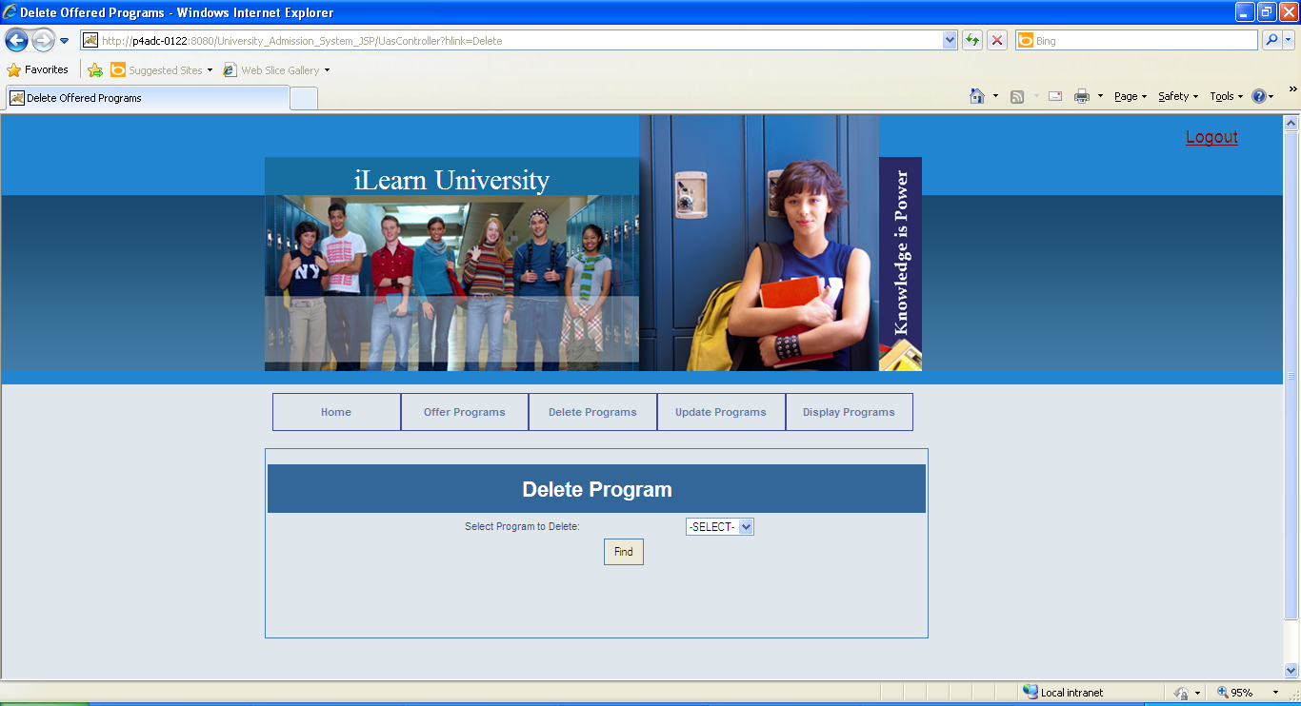

- Update Program Screen
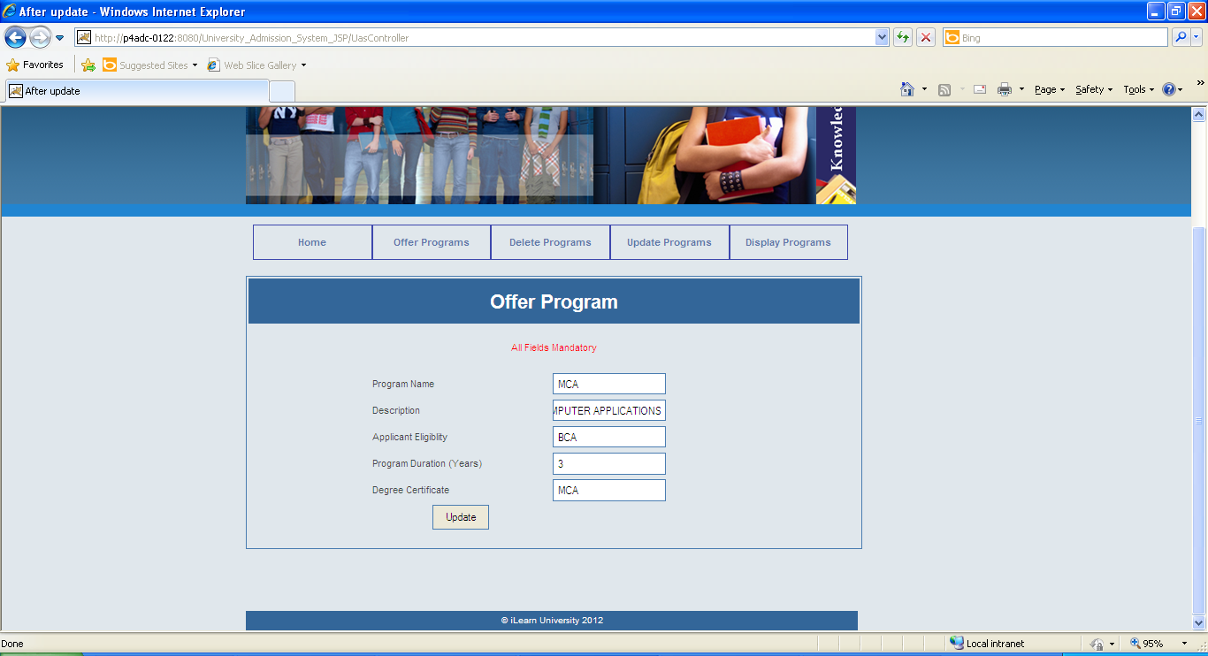

- View Programs Screen

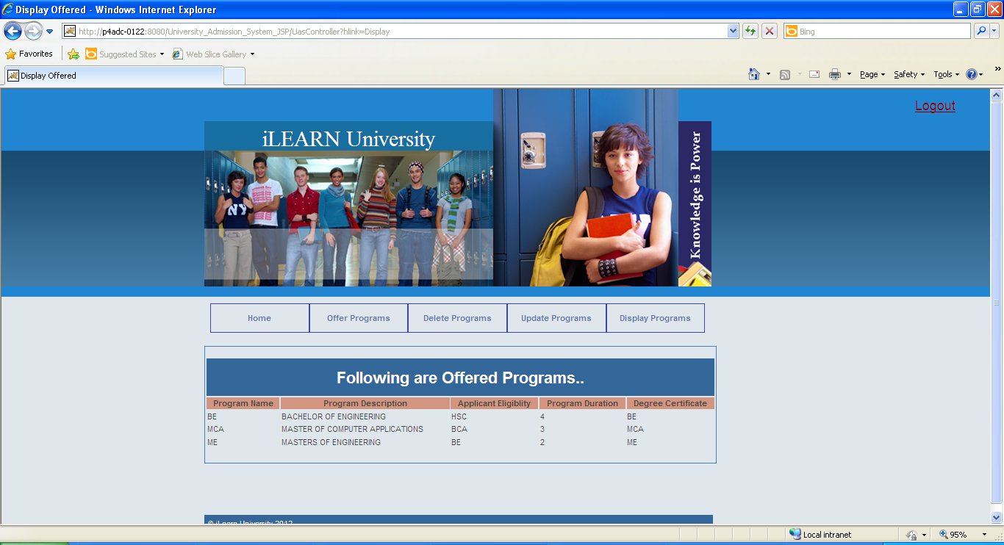
    - View Applications for Scheduled Program Screen: This screen should
only be available to authorized members of admission committee (mac).
He/She must be able to see the report based on id of a scheduled
program.
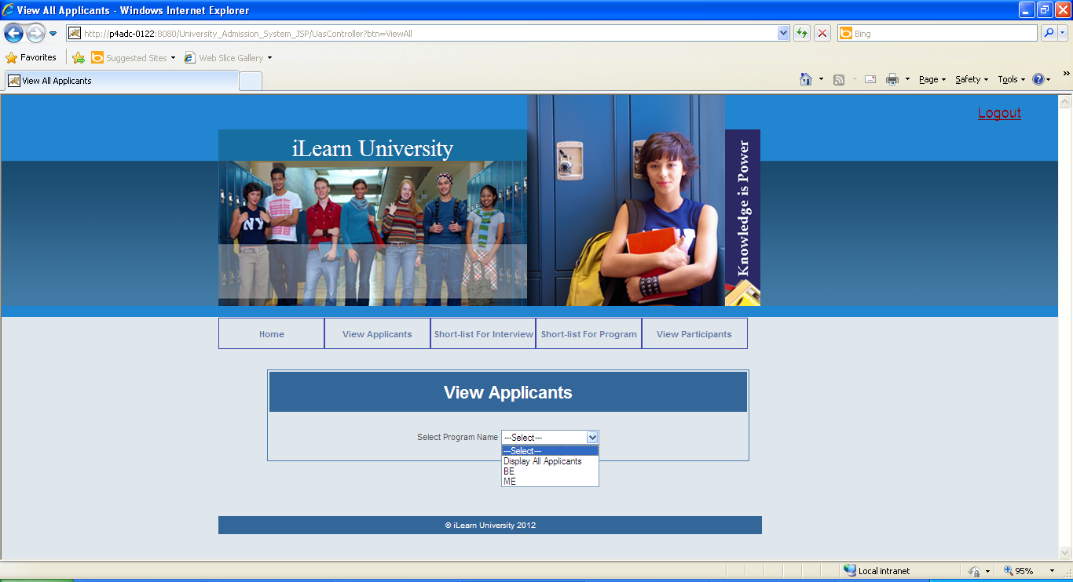
    - Filter Applicants Screen: This screen should only be available to
authorized members of admission committee (mac). He/She must be
able to view the participants for a specific scheduled program and
Accept/Reject the application, update the application status accordingly.
If the applicant is accepted for the program, an interview date should be
entered. If the applicant’s interview is conducted, the status should be
changed to either Confirmed or Rejected.
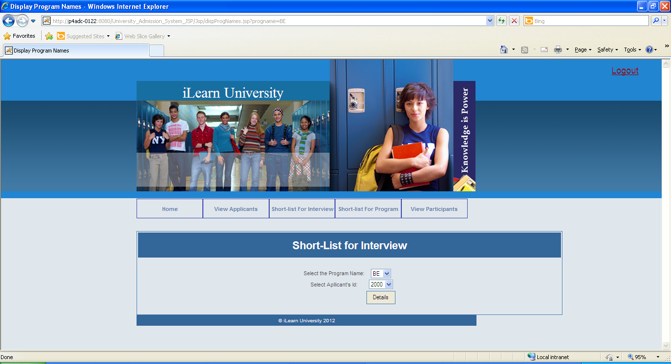

  - Test all other screens and links that appear in the application for
admin, MAC and Applicant.

  - Test the following functionality:

    - Login verification: This component will authenticate the user. Verify if the
user who is trying to access the system is a valid user. This verification is
as against the valid users listed in the users table, which has valid logins
for administrators and members of admission committee. There is no
login required for an applicant.
    - Retrieve Programs Scheduled: This component provides the applicant
with information on all programs scheduled by university.
    - Apply Online: This component should allow an applicant to submit his
application for a scheduled program only after performing obvious
validations on the entered data. An applicantion ID is auto generated and
shown to the applicant at the time of applying.
    - Retrieve Application Status: An applicant should be able to view the
status of application by entering the Applicantion id.

    - Maintain Program Information: This functionality should be available only
for authorized administrators. Administrations maintain information
includes Programs Offered (add/update/delete) and Programs Scheduled
(add/delete), only valid operations should be performed on the data. For
Ex. A program scheduled cannot be deleted /updated if there are
applicants for it.

    - Retrieve Applications for Scheduled Program : This should only be
available to authorized members of admission committee. He/She must
be able to view all the applicant data based on Scheduled program id

    - Filter Applicants: This component updates status of an application and
enter the date of interview only upon accepting an application. This
should only be available to authorized members of admission committee.
He/She must be able to view the participants for a specific scheduled
program and Accept/Reject the application, update the application status
accordingly. Status can be changed to ‘Confirmed’ only after, the
previous status was ‘accepted’ and the date of interview is present, dated
previous to or same as today’s date. If the applicant is accepted for the
program, an interview date should be entered. If the applicant’s interview
is conducted, the status should be changed to either Confirmed or
Rejected.

- Security :
Use https for security throughout the pages so that the valid users can only access the UAS.

Project Evaluation Guidelines
The project it is to be evaluated based on the following five parameters:

- Requirements Itemization (20 Marks)
  - Categorizing & writing requirements appropriately in the RVFD template.
  - Setting the appropriate priority for the requirements.
- Use Case (20 Marks)
  - Identifying correct Use Cases and creation of the same.
- Using TBA template to write test cases (20 Marks)
  - Effective Test Case writing using TBA template with appropriate input data, expected result & actual result.
  - Creating scenario matrix, use case level test cases, form level test cases, field level test cases, error table etc.
- Creation of defect report (20 Marks)
  - Writing defect free defects in the defect log
- Adherence to guidelines & complete solutions (10 Marks)
  - The participants needs to ensure that each & every artifact created during Mini Project activity should follow all the guidelines & best practices shared & taught during the training.
  - They also need to take care that all the expectations set for the successful completion of Mini Project are taken care of.
- Group Presentation and Query handling – (10 Marks)
  - Each participant is expected to present the Mini Project as a part of the group and as per the division of the responsibility/modules.
  - They are expected to handle the queries asked during the presentation in a satisfactory manner.

